|  |  |
| --- | --- |
| **Number of Observations Read** | 24 |
| **Number of Observations Used** | 24 |

| **Analysis of Variance** | | | | | |
| --- | --- | --- | --- | --- | --- |
| **Source** | **DF** | **Sum of Squares** | **Mean Square** | **F Value** | **Pr > F** |
| **Model** | 1 | 635.04186 | 635.04186 | 71.11 | <.0001 |
| **Error** | 22 | 196.46772 | 8.93035 |  |  |
| **Corrected Total** | 23 | 831.50958 |  |  |  |

|  |  |  |  |
| --- | --- | --- | --- |
| **Root MSE** | 2.98837 | **R-Square** | 0.7637 |
| **Dependent Mean** | 34.62917 | **Adj R-Sq** | 0.7530 |
| **Coeff Var** | 8.62963 |  |  |

| **Parameter Estimates** | | | | | |
| --- | --- | --- | --- | --- | --- |
| **Variable** | **DF** | **Parameter Estimate** | **Standard Error** | **t Value** | **Pr > |t|** |
| **Intercept** | 1 | 13.35530 | 2.59548 | 5.15 | <.0001 |
| **X1** | 1 | 3.32151 | 0.39388 | 8.43 | <.0001 |

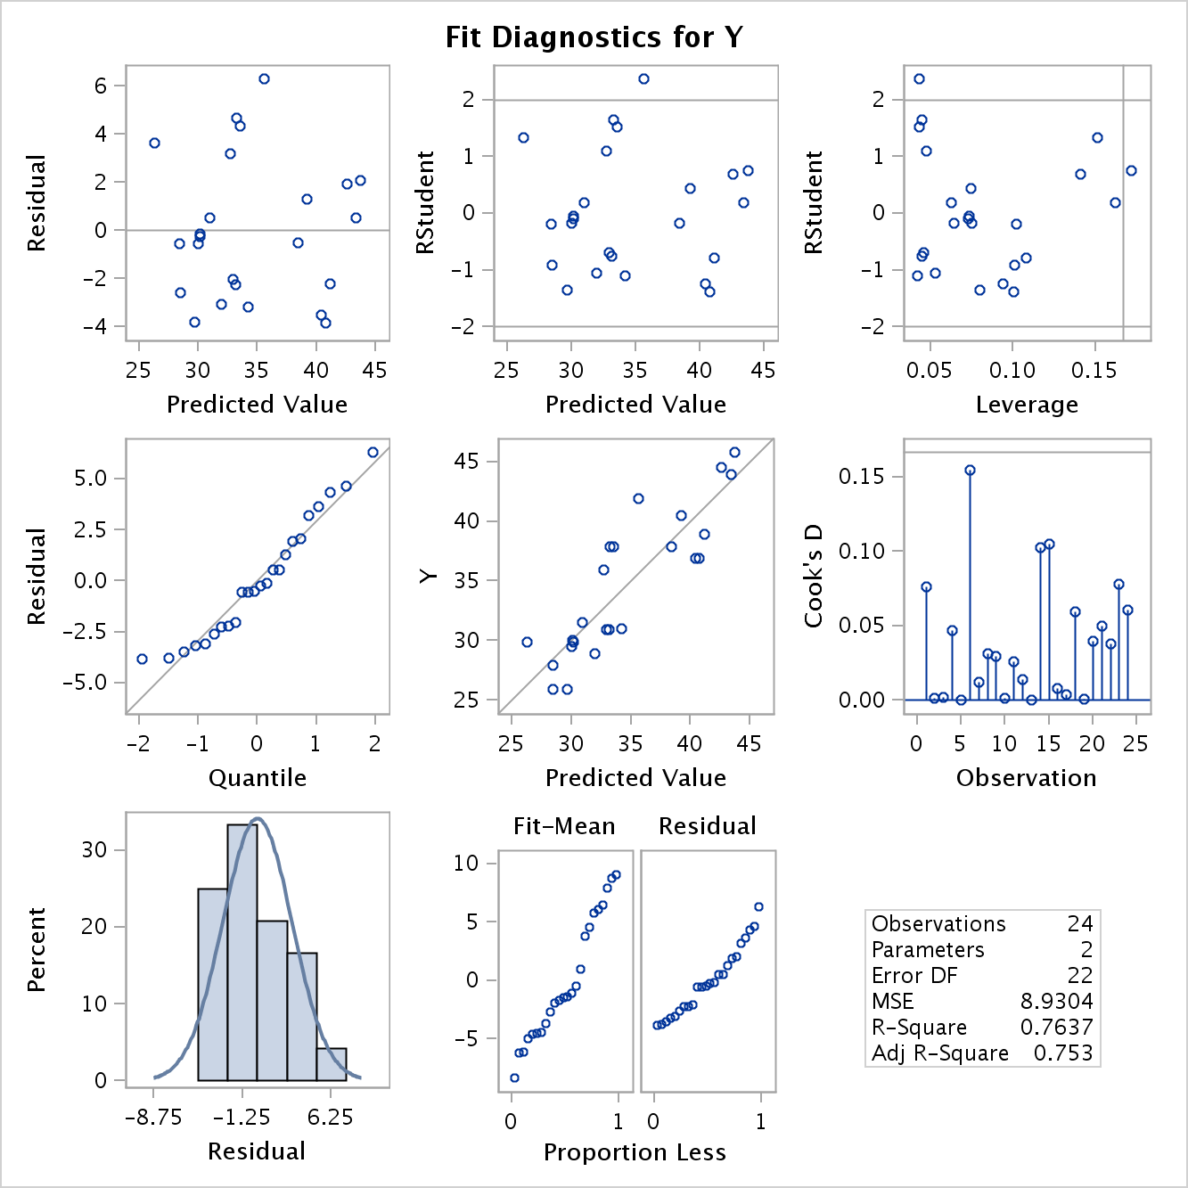

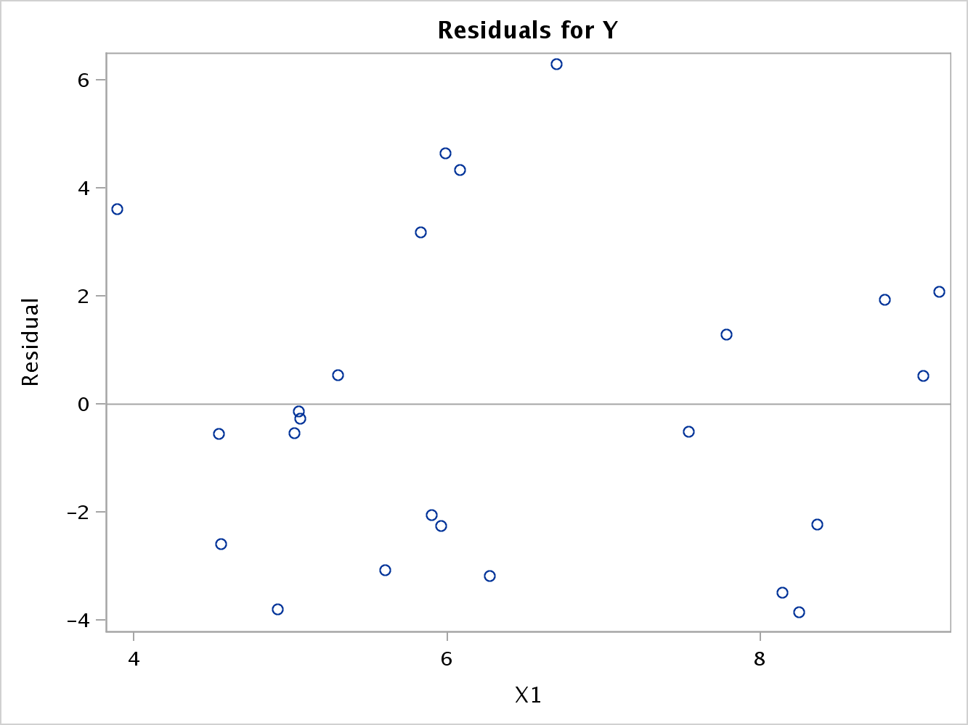

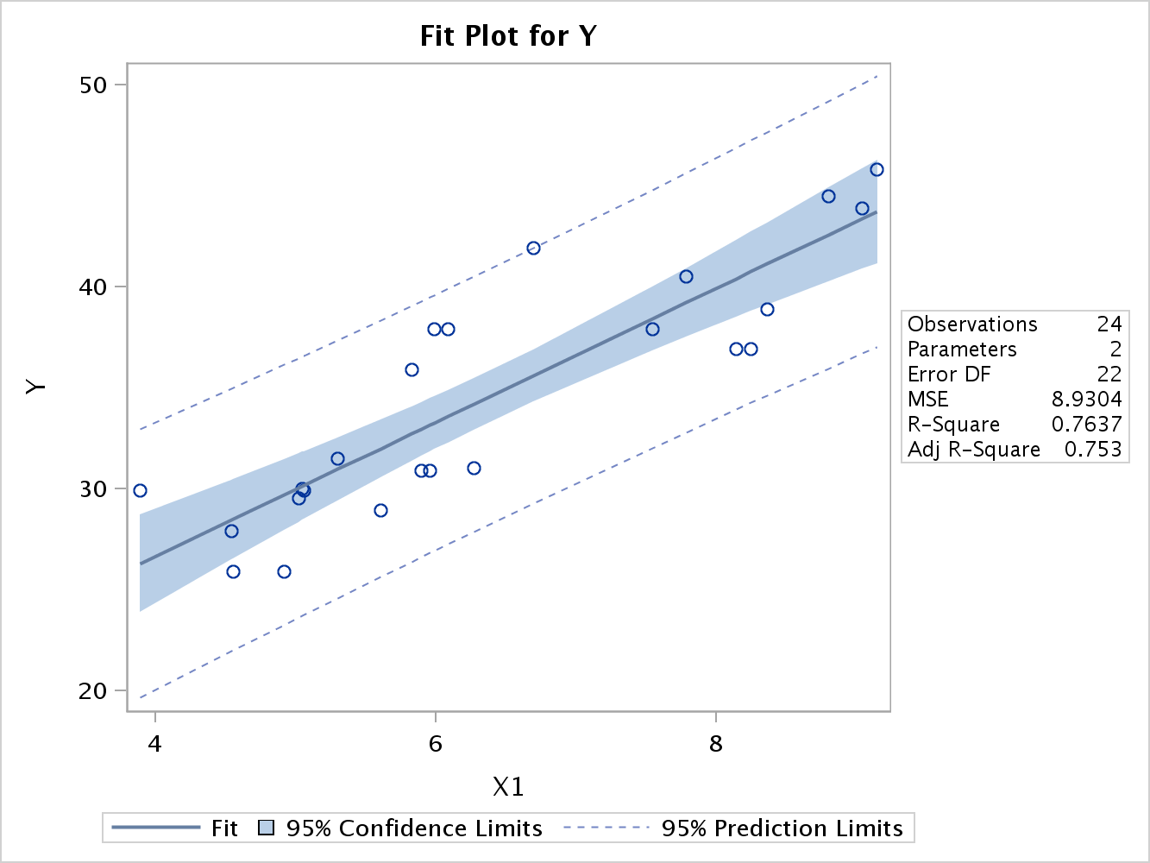

|  |  |
| --- | --- |
| **Number of Observations Read** | 24 |
| **Number of Observations Used** | 24 |

|  |
| --- |
|  |

| **Number in Model** | **R-Square** | **Adjusted R-Square** | **Variables in Model** |
| --- | --- | --- | --- |
| **1** | 0.7637 | 0.7530 | X1 |
| **1** | 0.5038 | 0.4812 | X2 |
| **1** | 0.5009 | 0.4782 | X4 |
| **1** | 0.4194 | 0.3930 | X3 |
| **1** | 0.2793 | 0.2465 | X6 |
| **1** | 0.2130 | 0.1772 | X5 |
| **1** | 0.1579 | 0.1197 | X8 |
| **1** | 0.0793 | 0.0374 | X7 |
| **1** | 0.0712 | 0.0290 | X9 |

|  |
| --- |
|  |

|  |
| --- |
|  |

